*Confirm the existence of the tables using these two sql commands:*

SHOW TABLES;

SHOW COLUMNS FROM users;

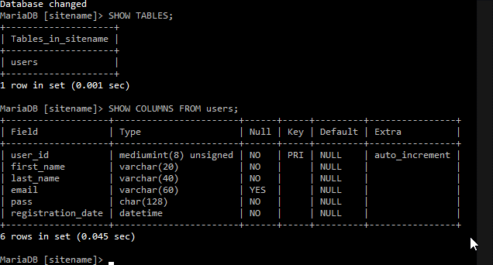

*Select all records and print them to the screen:*

*Select all records, but only print the Last Name and the First Name of the users:*

*Select all records from Last Name where the last names are between those that start with a C and those that start with a T. Format the query to read Last Name and then First Name:*

*Select all records from users where the last name is your last name. Show me all columns in this query related to your last name:*

*Select all records where the password is a password in your database. Must use SHA ( ) function to retrieve password:*

*Select all records where the Last Name starts with an A. (If you don’t have a last name that starts with an A, then use any other letter):*

*Select all records, that is not your name, and print them to the screen in descending order:*

*Select all users in your database and order by registration date in descending order, with a limit of 10 records, to be printed to the screen:*

*Update your database and replace an email for a single user, that is NULL, to the empty string:*

*Update your database using my name and email: Ian Lasky ian.lasky@rcc.edu:*

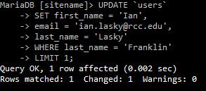

*Screenshot the result:*

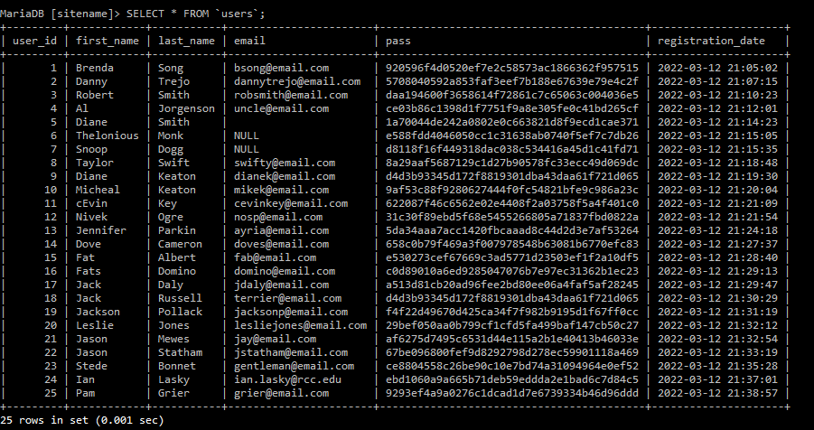

*Delete me from your database:*

*Select all records where email is NULL:*

This query returns all entries that don’t have a value in the email column.

*Select all records where email is the empty string:*

Unlike the previous query, an empty string is considered a valid value in this email column and can be searched for and retrieved by the database.

